Super Loop Project

Santiago Sanchez

Spring/Summer Co-op

**Table of Contents**

1 Introduction 1

2 Requirements 1

3 Design 1

3.1 Block Diagrams 1

3.2 Component Selection 3

3.3 Simulation (LTSPICE) 3

4 Testing 5

4.1 Test Setup 5

4.2 Step Response 7

4.3 Deviation (Small steps) 8

4.4 Frequency Response 9

5 Conclusion 10

**Table of Figures**

Figure 1. Super Loop Block Diagram 2

Figure 2. Nucleo Pinout and Circuit Block Diagram 2

Figure 3. Simulated Op-Amp Circuit 3

Figure 4. Transient Analysis of OP-AMP circuit 4

Figure 5. Full Circuit with I/P 4

Figure 6. Transient Analysis of Full Circuit 5

Figure 7. Test Stand 6

Figure 8. Step Response Test Resulting Graph 8

Figure 9. Deviation Test Resulting Graph 9

Figure 10. Magnified View of Graph 9

Figure 11. Frequency Response Test Resulting Graph 10

Figure 12. Testing I/P Voltage and Resistance 12

Figure 13. Linear Transducer Calculations 12

**Table of Tables**

Table 1. Components Used 3

Table 2. NI DAQ Modules 6

Table 3. Channels of DAQ 7

Table 4. Step Response Test Parameters 7

Table 5. Deviation Test Parameters 8

Table 6. Frequency Response Test Parameters 10

**Appendices**

Appendix A: BOM 9

Appendix B: Calculations 9

# Introduction

The purpose of the Super Loop Project is to recreate a Digital Valve Controller using a microcontroller. This will demonstrate the intricacies of what goes into making a real one along with the considerations of accuracy and responsiveness. The main microcontroller is an STM32 Nucleo-L476RG, it will take in an external setpoint with current ranging from 4-20mA. The DAC of the microcontroller will output a voltage which will be consistent with a circuit to output 4-20mA into an I/P. We will read valve travel with a Time-of-Flight sensor.

# Requirements

The microcontroller must take in an external 4-20mA setpoint, feedback on valve travel will be given through a VL53L4CX Time-of-Flight sensor, and a PI loop controls the voltage output. Proportional gain was set to 0.8 and Integral gain was 0.07. There were no performance requirements. A 165Ω shunt resistor was chosen to be used on the setpoint to allow the external setpoint to still fall in the range of the on-board ADC.

# Design

## Block Diagrams

Figure 1 was the original concept of how the system was going to work and is still accurate to how it is setup currently. Not every component was capable of being integrated such as the CPG2400 in Figure 1 which was going to act as a minor loop. The original concept was to use an STM32U5A9J-DK board with an integrated Time-of-Flight sensor and touch screen. This requires a lot more work to be done on the programming side as the biggest hurdle would be allowing the touch screen and peripherals to work together. The Time-of-Flight sensor that was on the board was not a ranging sensor and favored gesture detection.



Figure . Super Loop Block Diagram

Figure 2 shows the exact pins used on the STM32L476RG and the circuits that are involved with it. The board could not supply nearly enough current for the I/P so an OP-AMP circuit with a gain of 1 was first used. After testing, the gain that behaved the best with the I/P was 2.5. The OP-AMP would be supplied from an external power source and would have the capability to supply the current based on the input.



Figure . Nucleo Pinout and Circuit Block Diagram

## Component Selection

|  |  |
| --- | --- |
| Component | Purpose |
| 165Ω Resistor 0.1% Tolerance | Shunt resistor for input |
| 1kΩ Resistor | For op-amp gain |
| 1.5kΩ Resistor | For op-amp gain |
| AD711JNZ Op-Amp | Giving I/P sufficient power |

Table . Components Used

## Simulation (LTSPICE)

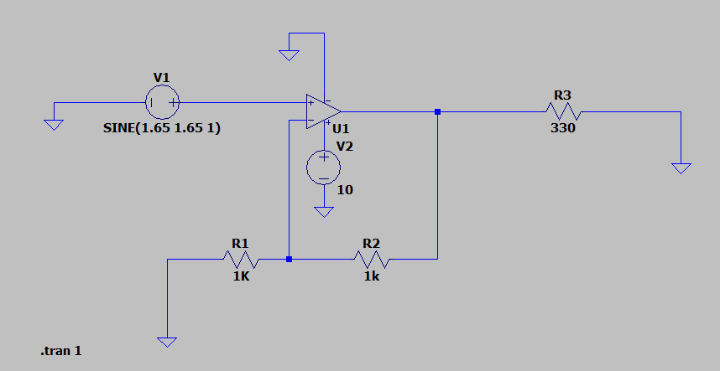

Figure . Simulated Op-Amp Circuit

Figure 3 illustrates the concept for the circuit that was going to be used. This was made to prove the circuit could work in the 4-20mA range. A gain of 2 was used here after finding out the I/P was going to need more than 3.3V to functions properly. Stepping up the voltage gives the I/P capability to use more of its range. R3 was chosen arbitrarily to limit the current to under 20mA in this situation.

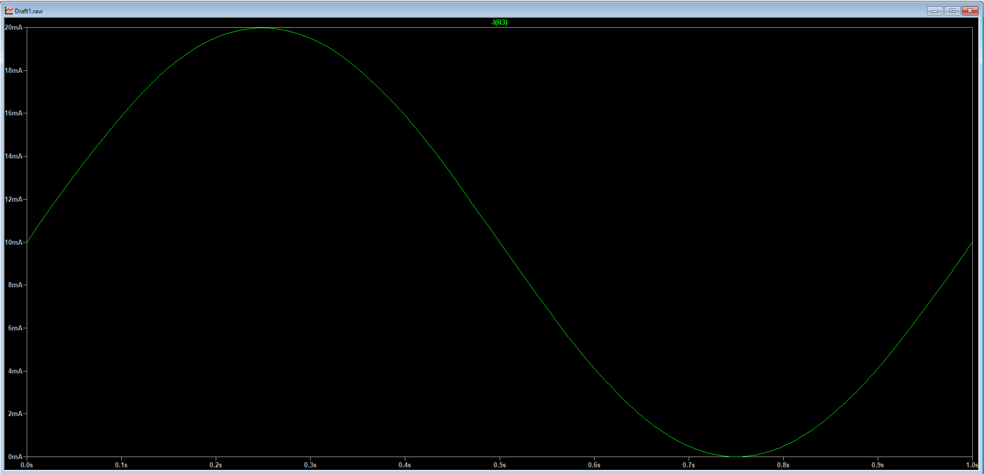

Figure . Transient Analysis of OP-AMP circuit

Through transient analysis we could see that this circuit could reach minimum and maximum current. The waveform shown in Figure 4 is the current measured across R3. This is over the course of time as V1 completes one cycle from 0-3.3V.

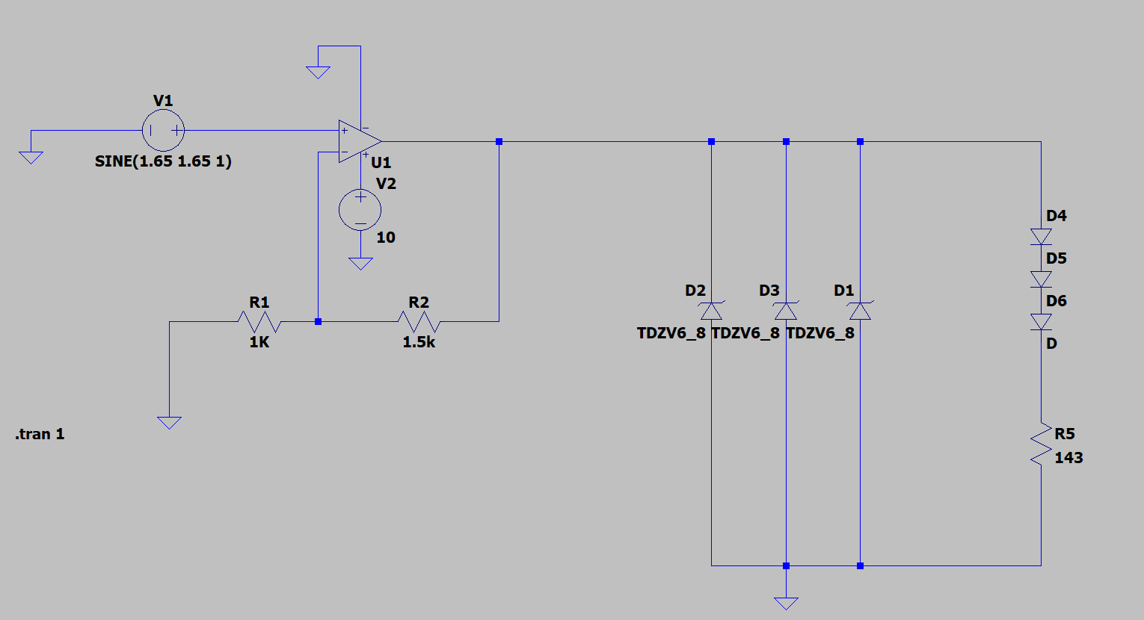

Figure . Full Circuit with I/P

Figure 5 is a representation of what the full circuit currently looks like. The I/P Circuit is not totally accurate because the inductance values are unknown. The gain was changed from 2 to 2.5 because in the real setup because the higher gain allowed the I/P to reach max pressure.

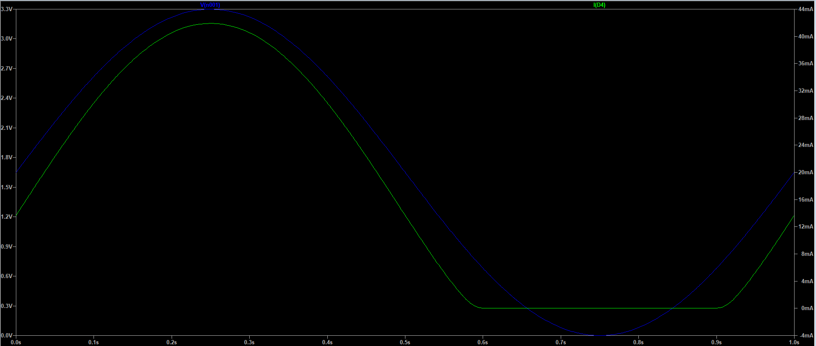

Figure . Transient Analysis of Full Circuit

Figure 6 is measuring the current going into D4-6 and R5. This is not at all accurate to the real current output because a resistor is used instead of the inductors. This analysis reports the current reaching 40mA, but the I/P will never go past 25mA because of current limit on power supply. The shape of the waveforms is still accurate to how the circuit behaves.

# Testing

## Test Setup

The circuit built will be as shown in Figures 1 & 2. A CompactDAQ will be setup to monitor the various parts of the circuit. The power supply for the OP-AMP will be set to a maximum of 18V and 25mA as those are the maximum limits of the OP-AMP. The Time-of-Flight sensor must be positioned under the travel platform as seen in Figure 7. The travel platform must have a bright colored piece of paper taped to the bottom to get the best measurement from the sensor.

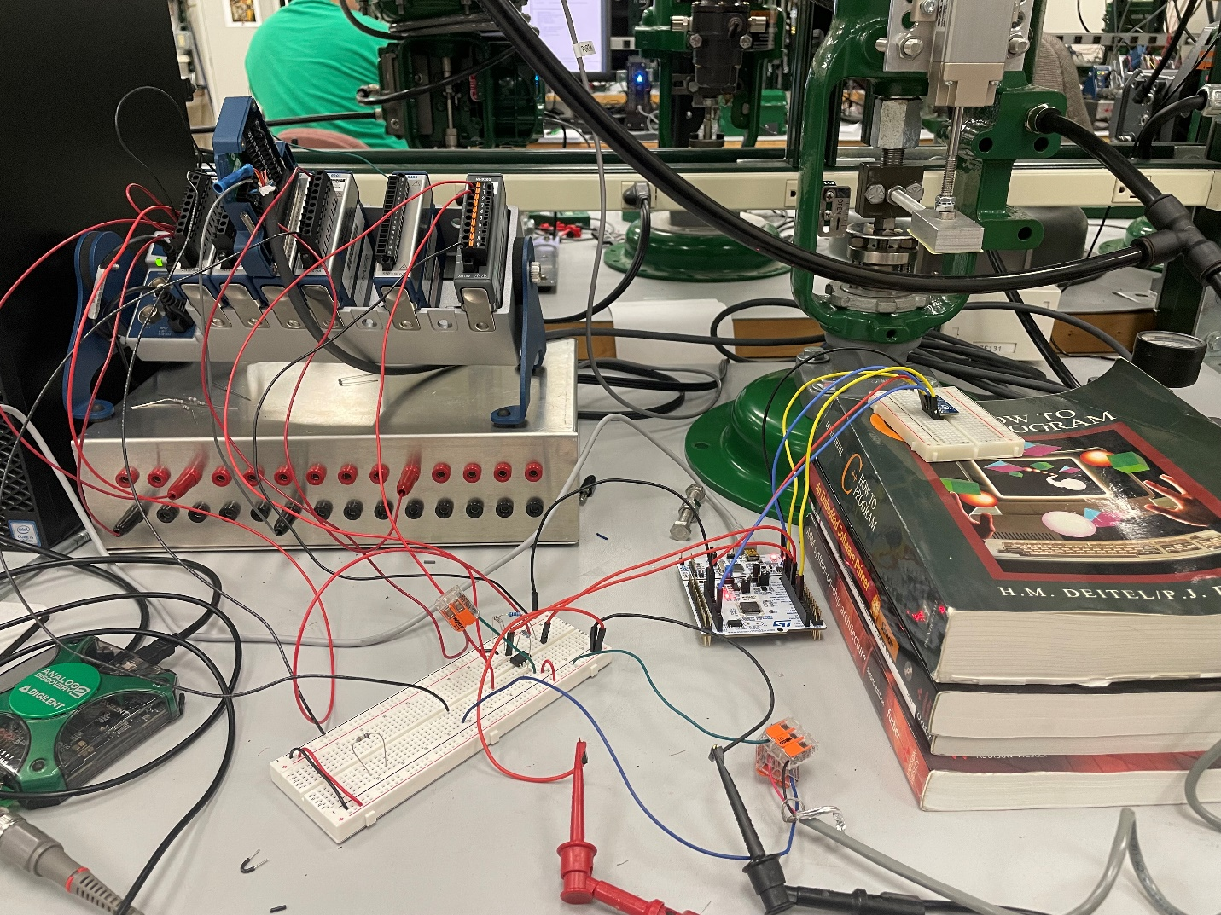

Figure . Test Stand

For testing, use the Analog Discovery 2 waveform generator for the input into the ADC. If using a voltage source, the range is 0.66-3.3V. All NI DAQ modules sample at 100Hz except the linear transducer which will sample at 1kHz. The op-amp will be supplied from an external power source with a Vmax of 18V. The linear transducer will be attached to the front of the actuator to give accurate travel to the NI DAQ. The linear transducer has a falloff current and takes time to settle. Full travel of the valve will be 2.38mA according.

|  |  |  |
| --- | --- | --- |
| NI DAQ Module | Function | Purpose |
| NI 9265 | Series Current Output | Give the 4-20mA setpoint |
| NI 9207 | Series Analog Input | Read the current from linear transducer to get accurate valve travel |
| NI 9203 | Series Current Input | Read current going into the I/P |
| NI 9201 | Series Voltage Input | Read voltage going into ADC, coming out of DAC, and into I/P |

Table . NI DAQ Modules

|  |  |  |
| --- | --- | --- |
| Channel Name | Unit | Details |
| Linear Transducer | mA | Reading raw current coming out of linear transducer |
| Linear Travel | mA | Converting “Linear Transducer” to read with other variables  Formula = -(‘Linear Transducer’) + 8.434 |
| Iout (OP_AMP) AI0 | mA | Reading current coming out of the op-amp into the I/P |
| Vin (MicroDAC) AI0 | V | Reading voltage coming out of the microcontroller’s DAC into the op-amp |
| Vout (OP-AMP) AI1 | V | Reading voltage coming out of the op-amp |
| Vset (MicroADC) AI2 | V | Reading voltage of the setpoint into the microcontroller’s ADC |
| Setpoint% | % | Converts “Vset” into a percentage (0.66-3.3V) |
| Travel% | % | Converts “Linear Travel” into a percentage (0-2.9mA) |

Table . Channels of DAQ

## Step Response

Setpoint is given by the Analog Discovery 2. Data is collected from NI FlexLogger. The waveform generator will start at 50% setpoint (1.98V) and increment or decrement by 25% intervals for 3 cycles.

|  |  |
| --- | --- |
| Test Parameter | Value |
| Amplitude | 0.66V |
| Offset | 1.86V |
| Low Voltage | 1.32V |
| High Voltage | 2.64V |
| Total Test Time | 300s |
| Settle Time | 20s |
| Period of Step Test | 10 mHz |
| Step Increments | 25% (0.66V) |
| Number of Cycles | 3 |

Table . Step Response Test Parameters

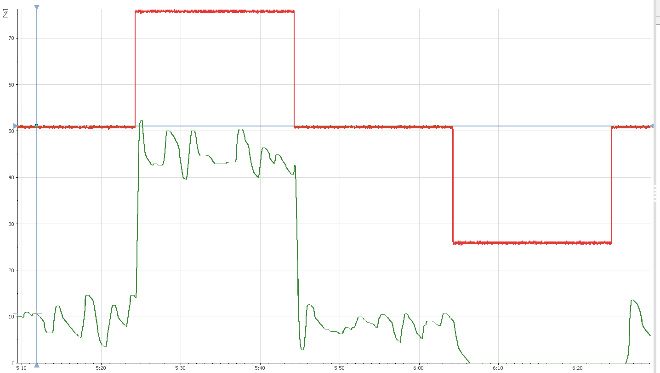

Figure . Step Response Test Resulting Graph

## Deviation (Small steps)

This test will step through the entire range for the setpoint in 10% increments (0.264V). The steps will have an increased settle time of 30 seconds to measure full range of deviation. The waveform will begin at the midpoint of 1.98V, move up to maximum, and then move down to minimum.

|  |  |
| --- | --- |
| Test Parameter | Value |
| Amplitude | 1.32 |
| Offset | 1.98 |
| Low Voltage | 0.66V |
| High Voltage | 3.30V |
| Total Test Time | 600s |
| Settle Time | 30s |
| Period of Step Test | 1.6667mHz |
| Step Increments | 10% (0.264V) |
| Phase | 90° |

Table . Deviation Test Parameters

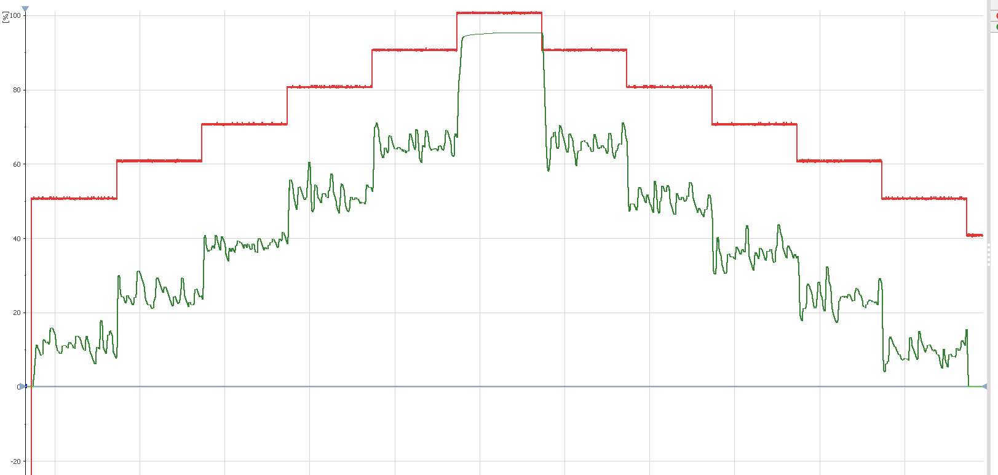

Figure . Deviation Test Resulting Graph

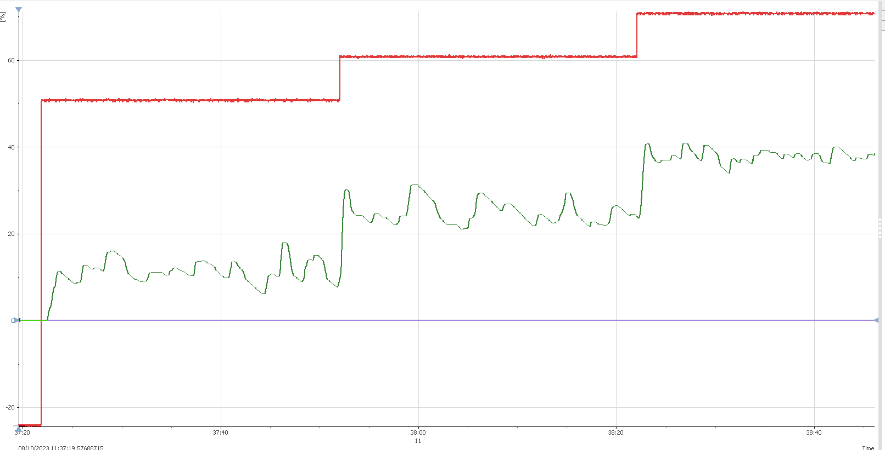

Figure . Magnified View of Graph

## Frequency Response

Frequency sweep is given by the Analog Discovery 2. The waveform generator will create a sine wave that oscillates through the entire setpoint range. The frequency of the wave will start at 1mHz and increase to 1Hz in the span of 3 minutes.

|  |  |
| --- | --- |
| Test Parameter | Value |
| Amplitude | 1.32V |
| Offset | 1.98V |
| Low Voltage | 0.66V |
| High Voltage | 3.30V |
| Starting Frequency | 1mHz |
| Ending Frequency | 1Hz |
| Total Sweep Time | 3 Minutes |

Table . Frequency Response Test Parameters

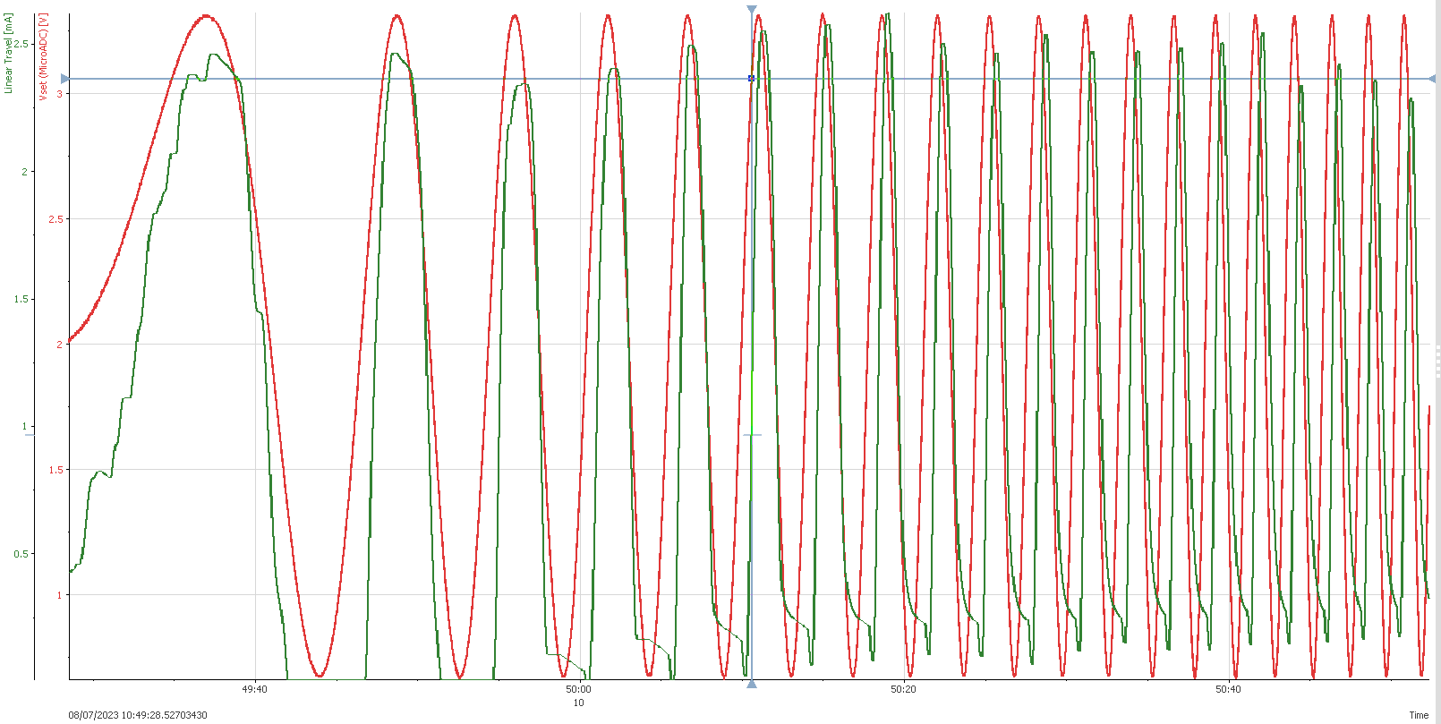

Figure . Frequency Response Test Resulting Graph

Resulting Break Frequency: ~0.5Hz

# Conclusion

The Super Loop still has room for improvement. The system seems to not respond below 1.47V which should in range. A big factor is the noise of all the components along the loop which can be mitigated by oversampling the ADC, further tuning of the PID loop, and adding capacitance into the input circuit. Suggested add-ons to improve accuracy would be to find the raw counts of the Time-of-Flight sensor and use those instead of millimeters to increase the precision of the feedback. The full range of the Time-of-Flight sensor is 19mm which makes each mm worth 5%.

Appendix A: BOM  
[SuperLoop BOM.xlsx](https://emerson-my.sharepoint.com/:x:/p/santiago_sanchez/EaMJsUomgOBLhdJNsEzAYnkBJF4-g6XHG2FYL0CPlC8JrA?e=suXliC)

|  |  |  |  |  |  |  |
| --- | --- | --- | --- | --- | --- | --- |
| Description | Part Number | Manufacturer | Quantity | Datasheet | Description | Comments |
| Digital Pressure Gauge | CPG2000 | Mensor | 1 | [Link](https://www.mensor.com/media/Data-sheets/Calibration/Digital-pressure-gauges/ds_cpg2400_digital_pressure_gauge_en_um.pdf) | Measure pressure out of the I/P into the actuator |  |
| RS232 Shifter | PRT-00449 | Sparkfun | 1 | [Link](https://media.digikey.com/pdf/Data%20Sheets/Sparkfun%20PDFs/PRT-00449_Web.pdf) | Allow communication from Digital Pressure Gauge to Micro |  |
| RS232 Cable | EDN12H-0005-MM | CDW | 1 | [Link](https://assets.tripplite.com/product-pdfs/en/p450006.pdf) | Cable between Micro and Gauge | Standard serial, non null modem |
| 165 Ω Resistor 0.1% | YR1B165RCC | TE Connectivity | 1 | [Link](https://www.te.com/commerce/DocumentDelivery/DDEController?Action=srchrtrv&DocNm=1773265&DocType=DS&DocLang=English) | Measure voltage drop across ADC and calculate current |  |
| Power Supply | E3646A | Keysight | 1 | [Link](https://www.keysight.com/us/en/assets/7018-06827/data-sheets/5968-7355.pdf) | Give a stable voltage to the OP-AMP |  |
| OP-AMP | [AD711JNZ](https://www.digikey.com/en/products/detail/analog-devices-inc/AD711JNZ/671001) | Analog Devices | 1 | [Link](https://www.analog.com/media/en/technical-documentation/data-sheets/AD711.pdf) | Amplify voltage to drive higher current |  |
| Pin Headers | 2011-1X09TR | [Oupiin](https://www.digikey.com/en/supplier-centers/oupiin) | 1 |  | Solder onto breakout board |  |
| STM32 Microcontroller | NUCLEO-476RG | STMicroelectronics | 1 | [Link](https://www.st.com/en/microcontrollers-microprocessors/stm32l476rg.html#documentation) | Main controller of the loop |  |
| Time-of-Flight Sensor | VL53L4CX | STMicroelectronics | 1 | [Link](https://www.st.com/resource/en/datasheet/vl53l4cx.pdf) | Measures valve travel using light | Must be a ranging sensor |

Appendix B: Calculations  
[Superloop_Calculations.xlsx](https://emerson-my.sharepoint.com/:x:/p/santiago_sanchez/Effli2QwrkJNkJvjc-TeysMB9g-wDHfYszVHZN4zkgwerw?e=sX0HYN)

Figure . Testing I/P Voltage and Resistance

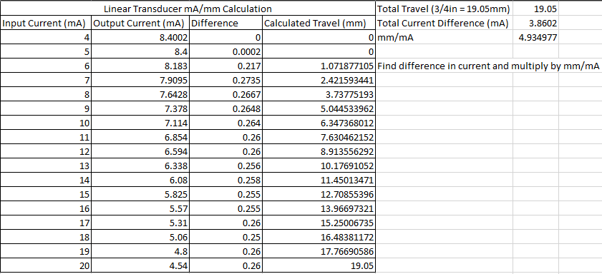

Figure . Linear Transducer Calculations